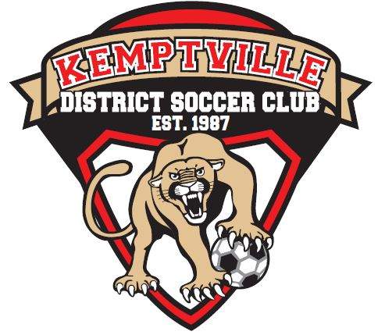

Kemptville District Soccer Club
2022 Annual General Meeting
Tuesday October 25, 2022 – 19:00 – Virtual (Zoom)

Meeting called to order at 19:04
Opening remarks were provided by Robert Fnukal

Credentials Report:
The current members of the board who were in attendance were introduced to the membership as follows:
- Rob Fnukal (Discipline Chair) (non-voting)
- Alan Archer (Club Manager) (non-voting)
- John Tucker (Club Head Referee) (non-voting)
- Marcus Dickie (Club Head Coach) (non-voting)
- Mike Sutherland (President)
- Jeff Fluit (Treasurer)
- Jamie Brown (Director Competitive Operations)
- Shannon Kenward (Director Development)
- Rance Young (Director House League)
- Nicole Craig-Campbell (Director Equipment Competitive)

Notes:
- Board Members Absent: Hailee Coleman (Director Registration), Helen Grus (Director Equipment House League), Cameron Duff (Vice-President)
- Participants/Members in attendance: Nehemie Jean, Stanley Degand

Approve Draft Minutes of 2021 AGM:
Draft minutes of the 2021 AGM were posted on the KDSC website for the membership.
Nicole moved to approve the 2021 AGM draft minutes. Jeff seconded, all in favor. Motion to accept the 2021 AGM minutes was passed.

President’s Report:
Mike Sutherland discussed key elements of his report and is available to membership on the KDSC website:
- Return to a more normal season from the challenges of the cancelled/abbreviated 2020/2021 seasons due to Covid-19 now seemingly behind us
- The 2022 season focused on the rebuilding of the Club’s financial stability, having to implement a challenging new OSA player card/registration system that had a number of issues encountered and to welcome the return of our existing/new members to our local KDSC soccer program
- This year will be the final year as President as stepping aside with 20+ years of volunteering (coaching, Director Competitive and President roles)
- Proud in that the Club invests in coach development and referee development
- Proud to have an excellent group of resolute volunteers within the Board that make our grassroots soccer program one of the best within the region aligned to Development soccer with the proper strategic direction in place to ensure continued growth, competitive success, and improvement. We know who we are and what we are not.

Treasurer’s/Auditor’s Report:
Jeff Fluit provided an overview of the report and is available to membership on the KDSC website. Key details include:
- Projected small budget surplus at the completion of 2022 season
- 2022 equipment costs were reduced as compared to a normal season due to Covid-19. Uniforms that were purchased for the 2020 season were used during the 2022 season.
- Field costs include paint for lines for the fields for the 2023 season. Paint was exceedingly difficult to obtain during the 2022 season due to supply chain issues; but the club was able to secure a supply for the 2023 season

Appointment of Auditor for 2022 Financial Audit:
Treasurer Jeff Fluit recommended continuing with Walker and Associates for the 2022 audit. Mike Sutherland moved to approve continuation with Walker and Associates, Nicole Craig-Campbell seconded, all in favor. Motion to accept Walker and Associates for the 2022 audit.

Club Head Coach Report:
Marcus Dickie provided an overview of the report and is available to membership on the KDSC website. Key details include:
- 2022 Season Review-impressed to see number of returning coaches and new coaches
- 2021-2022 Winter Program-school board permit restrictions in place until January 2022, players allowed in gymnasium end of February, so they played outdoors until mid-November 2021
- 2022 Competitive/Development Assessments-new coaches at the development level
- 2022 Technical Sessions-implemented 5-week skills development program with strong participation by the players (80-90 range). Coach active participation remains to be an opportunity for improvement (same 3-4 always attended)

Club Head Referee Report
John Tucker provided an overview of the report and is available to membership on the KDSC website. Key details include:
- The number of games returned to normal 2019 levels; but the return rate of match officials was only 40% province wide. By the end of season, KDSC level was up to 50% for match officials (13 officials total). Some match officials were covering 5-6 nights/week
- Due to the small number of match officials within KDSC, many of the youth house league games were played without a match official as was the consistent availability for Assistant Referees for the EODSL/OCSL competitive teams. Main challenges were on Sunday evenings (MHL/MC4) or Tuesday evenings (BU16C2/GU16C1) playing on the same night
- Plans have the winter education sessions (Laws of the Game changes, dealing with coaches, foul recognition) slated for January-March via Zoom for all returning referees and AR refresher session in May

Director Development and Competitive Operations Report:
Jamie Brown provided an overview of the report and is available to membership on the KDSC website. Jamie covered two portfolios for the 2022 season. Key details include:
- Sixty-five percent return rate of development/competitive players for assessments/team formation for 2022 season. Expectation was around 60% return rate
- Combined age group strategy put in place (U10, U12, U14, U16 and U18) which served well for the teams this season as EODSL structured leagues of U13/14C2 and U15/16C2
- 3 X Youth Development Teams and 5 X Competitive Teams ran for the 2022 season
- New coaching/management staff in place for Development Teams, many returning coaches/management staff in place for Competitive Teams
- Youth competitive teams had strong seasons in 2022. The GU16’s was offered a promotion letter by the ERSL to move up to GU17 Regional for the 2023 season.

Director House League:
Rance Young provided high level overview of the house league program ran for the 2022 season. There were close to 800+ players registered to play in the KDSC house league program (U3 to U18).

Unfinished Business:
There were no items of unfinished business from 2021 season.

Amendments to Bylaws and Constitution:
There were no amendments to bylaws and constitution put forth during the 2022 season.
The Not-for-Profit Act has been updated and provided to KDSC. KDSC bylaws/constitution changes may be required and be in place by end of 2023.

Election of Officers and Directors:
The positions up for election at the 2022 AGM:
- President (2-year term)
- Secretary (2-year term)
- Director Competitive Operations (2-year term)

Election of President:
There were no nominations and no volunteers. This position remains vacant.

Election of Secretary:
There were no nominations and no volunteers. This position remains vacant.

Election of Director Competitive Operations:
There were no nominations and no volunteers. This position remains vacant.

Other Business:
No other business items have been submitted to KDSC.

Adjournment:
The next board meeting is Tuesday, November 8th, 2022, at 19:00 via Zoom. The board meets on the first Tuesday of every month except for the summer.

Motion to adjourn the 2022 AGM was made by Nicole Craig-Campbell, Jeff Fluit seconded. All in favor, motion passed. Meeting adjourned at 19:46.

